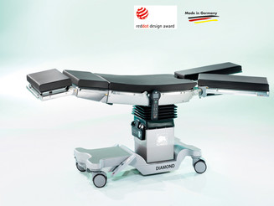
OT Table:
DIAMOND:
DIAMOND, an operating table in a class of its own. You will get maximum comfort and leading reliability for your everyday clinical practice.
DIAMOND- the operating table for the most demanding requirements. Made in Germany, winner of the Reddot Design Award and has been nominated for the German Design Award.
For more information Please Click Here

https://schmitz-soehne.com/en/products/diamond
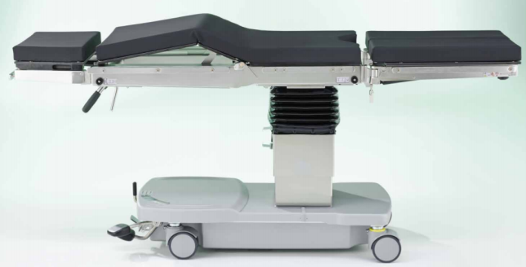
OPX mobilis:
OPX mobilis, the all-rounder of operating tables. It is exemplary flexibility and reliability for medical practices, outpatient use and in the OR theater. It is Made in Germany.
For more information Please Click Here

https://schmitz-soehne.com/en/products/opx-mobilis

OT Light:
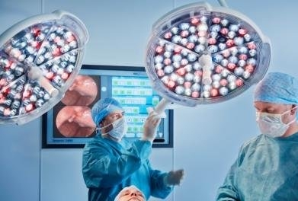
Brandon Medical is a UK manufacturer and designer of world-leading technology for operating theatres Lights.
Brandon Medical provides a comprehensive range of LED medical lights to suit all of your clinical needs. Brandon Medical’s LED medical lights use the latest innovations in LED lighting technology to provide you with better performance and lower lifetime costs.
For more information Please Click Here

https://www.brandon-medical.com/products/medical-lighting/operating-lights/quasar-elite-hd-led

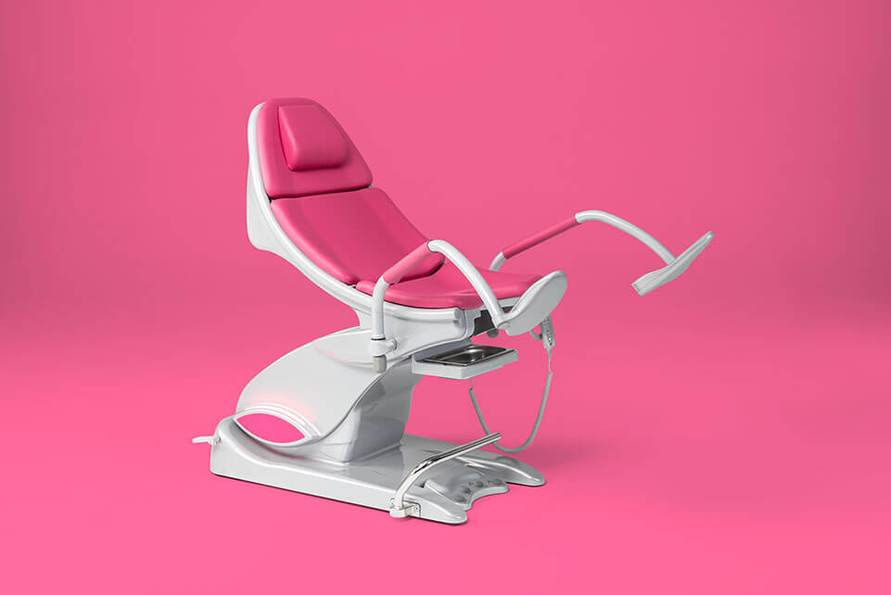
Gynecological Examination Chairs:
arco – optimized use, high level of comfort, first-class design
The next generation of gynecological examination chairs unites functionality, outstanding comfort and innovative technology with a first-class design.
A benchmark for quality and design: the arco has won the prestigious reddot Design Award.
For more information Please Click Here

https://schmitz-soehne.com/en/products/arco/
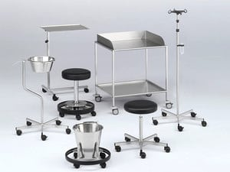
OR theatre Accessories
The accessories required for day-to-day OR theatre work in recognized quality.
Functional, hard-wearing and made using electro polished chromium-nickel steel for improved cleaning and disinfection properties.
For more information Please Click Here

https://schmitz-soehne.com/en/products/varimed-furniture-for-or-theatres/

